# Experiment: Acceleration down an inclined plane Time allocated: 40 min

**Aim**

To experimentally determine the value of the gravitational acceleration constant () at the surface of the Earth using the motion of a ball rolling down a ramp.

**Background**

In the absence of friction, the acceleration () of a ball rolling down a ramp depends only on the angle of incline ().

With a suitable equation of motion, the acceleration of the ball can be calculated, and used to determine the gravitational acceleration constant.

**Equipment**

1. Wooden Ramp 2. Marble 3. Ruler 4. Stopwatch 5. Calculator

**Diagram of Setup**

height

ϴ

Marble

Ramp

1. Describe how you would determine the acceleration of the ball **and** the angle of incline of the ramp for a single trial using **only** the equipment in the list above. Include the measurements that need to be taken and a description of any calculations needed to be performed. [6 marks]

**Observations**

|  |  |  |
| --- | --- | --- |
| Incline angle (degrees) | Acceleration (m s-2) |  |
| 5.0 | 0.52 |  |
| 15 | 1.7 |  |
| 20 | 2.4 |  |
| 25 | 3.0 |  |
| 30 | 3.6 |  |

1. Produce a **linear** graph to show the relationship between acceleration and the angle of the incline of the ramp. You may use the extra column in the table to help you but is not required. [6 marks]

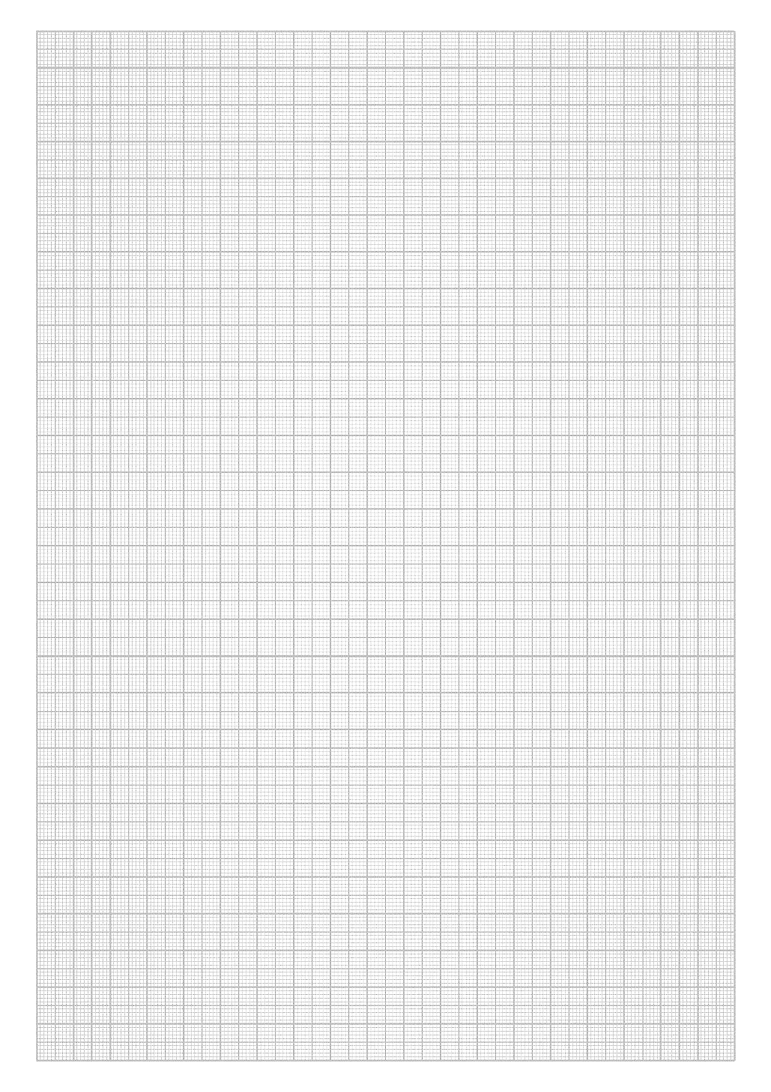

1. Assume that the acceleration of the marble and the angle of incline both have a 10% uncertainty. Draw in the error bars on your graph for the plotted point when the incline angle was 250. [2 marks]
2. Determine the gradient of the graph. Include units. [3 marks]
3. Using the gradient, determine the experimental value for the acceleration due to gravity (). Explain your reasoning. [2 marks]
4. Determine the percentage difference between your experimentally determined value of the acceleration due to gravity and the currently accepted value of the acceleration due to gravity. [1 mark]
5. State a **major** source of error you expect has influenced this experiment. Suggest a method to minimise this error. [2 marks]